**WEB DEVELOPMENT INTERNSHIP**

**PROJECT 1**

# **Project Title: Landing Page Development**

## **Objective:**

The objective of this project is to develop a visually appealing, responsive, and interactive landing page using **HTML, CSS, and JavaScript**. The landing page will feature a **hero section, dropdown navigation, key features, and a footer**, ensuring a seamless user experience across devices.

**Introduction:**

This document explains the development of a responsive and visually appealing landing page using **HTML, CSS, and JavaScript**. The landing page includes a **hero section, dropdown navigation, key features section, and a footer**.

1. **HTML Structure :**

HTML (**HyperText Markup Language**) structures the content of the webpage.

**Key Components:**

* **<header>:** Contains the website logo and navigation menu.
* **<nav>** and **<ul>**:Defines the navigation links and dropdown menus.
* **<section class='hero'>**: Hero section with a background image, heading, and CTA button.
* **<section class='features'>**: Displays product/service features.
* **<footer>:** Includes copyright information and legal links.

**HTML Code :**

<!DOCTYPE html>

<html lang="en">

<head>

<meta charset="UTF-8">

<meta name="viewport" content="width=device-width, initial-scale=1.0">

<title>Landing Page</title>

<link rel="stylesheet" href="styles.css">

<script defer src="script.js"></script>

<link rel="stylesheet" href="https://cdnjs.cloudflare.com/ajax/libs/font-awesome/6.0.0/css/all.min.css">

</head>

<body>

<header>

<div class="logo">MyWebsite</div>

<nav>

<ul class="nav-links">

<li><a href="#">Home</a></li>

<li class="dropdown">

<a href="#">Features <i class="fas fa-chevron-down"></i></a>

<ul class="dropdown-menu">

<li><a href="#">Feature 1</a></li>

<li><a href="#">Feature 2</a></li>

<li><a href="#">Feature 3</a></li>

</ul>

</li>

<li class="dropdown">

<a href="#">Services <i class="fas fa-chevron-down"></i></a>

<ul class="dropdown-menu">

<li><a href="#">Service 1</a></li>

<li><a href="#">Service 2</a></li>

<li><a href="#">Service 3</a></li>

</ul>

</li>

<li><a href="#">Contact</a></li>

</ul>

</nav>

</header>

</body>

</html>

* Here, First I create a new folder in desktop and named it as LandingPage
* Now , I save above html file as index.html and place this file inside the LandingPage

**2. CSS for Styling:**

CSS (**Cascading Style Sheets**) is used for styling and responsiveness.

**Key Features:**

* **Header & Navigation:** Styled for easy navigation with dropdown functionality.
* **Hero Section:** Full-width background with text overlay.
* **Features Section:** Uses Flexbox for a structured layout.
* **Responsive Design:** Media queries adjust layout for different screen sizes.

**CSS Code :**

body {

font-family: 'Arial', sans-serif;

background-color: #f4f4f4;

color: #333;

}

/* Hero Section */

.hero {

text-align: center;

background: url('https://source.unsplash.com/1600x900/?technology') no-repeat center center/cover;

color: white;

height: 80vh;

display: flex;

align-items: center;

justify-content: center;

}

/* Navigation Dropdown */

.dropdown-menu {

display: none;

position: absolute;

background: white;

min-width: 150px;

box-shadow: 0px 4px 6px rgba(0, 0, 0, 0.1);

z-index: 1000;

}

.dropdown:hover .dropdown-menu {

display: block;

}

* Here, I save above css file as styles.css and place this file inside the Landing page folder

**3. JavaScript for Interactivity :**

JavaScript (JS) adds interactivity to the page.

Functionality:

* Toggles the mobile menu.
* Enables dropdown menus.

**JavaScript Code :**

document.addEventListener("DOMContentLoaded", function () {

const navLinks = document.querySelector(".nav-links");

const toggleNav = document.createElement("button");

toggleNav.textContent = "☰";

toggleNav.classList.add("menu-toggle");

document.querySelector("header").appendChild(toggleNav);

toggleNav.addEventListener("click", function () {

navLinks.classList.toggle("active");

});

});

* Here, I save this java script file as script.js and save this file inside the Landing Page folder
* Then, Open index.html in your browser.
* Click on items to mark them as done.

**Output :**

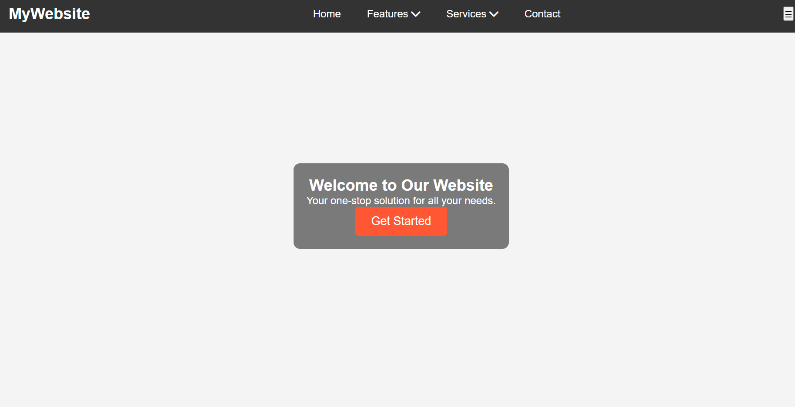

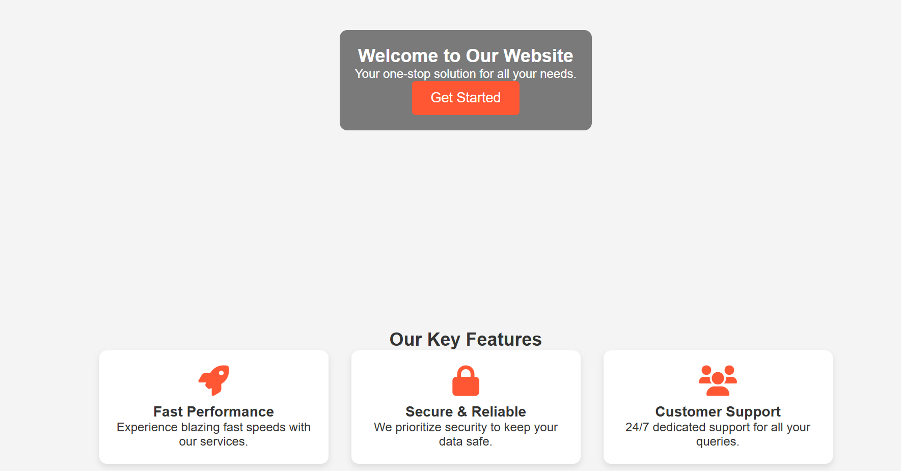

**Conclusion :**

This project successfully demonstrates the creation of a responsive and visually appealing landing page using HTML, CSS, and JavaScript. By implementing a structured layout, dropdown navigation, and a well-designed hero section, we have enhanced both usability and user experience. The use of media queries ensures that the webpage is adaptable to different screen sizes, making it mobile-friendly.

Through this project, I gained practical experience in frontend development, responsive design principles, and interactive navigation menus. This serves as a strong foundation for more advanced web development projects in the future.